**Health & Safety Talk**

Toolbox Talk

**Understanding OHS and OHS Law**

OHS law is an extremely complex system to understand. There are a number of legislative guidelines than need to be followed to comply with OHS law. The most user friendly reference to follow in helping you to reach the higher compliance standards are by following the Codes of Practice/ Compliance Codes. These are issue specific documents that help you to understand your requirements and provide direction as to how to meet these in a user friendly format.

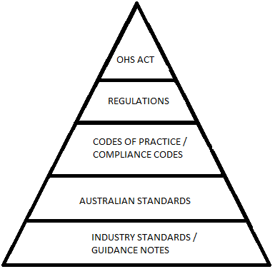

The governing piece of legislation in Victoria is the Occupational Health and Safety Act. Not only does the employer have duties under the Act, employees also have duties under the Act. Under the Occupational Health and Safety Act, it states that:

Whilst at work, an employee **must**:

* Take reasonable care of his or her own health and safety;
* Take reasonable care for the health and safety of persons who may be affected by the employee’s acts or omissions at a workplace; and
* Co-operate with his or her employer with respect to any action taken by the employer to comply with requirements under the Act or Regulations.

It is important to remember, OHS compliance is a business wide requirement, not just that of the businesses management.

|  |  |
| --- | --- |
| **Consultation** |  |

**Date of Meeting:**_____________________

**Attendees** (list attendees present)

|  |
| --- |
|  |

**Items Discussed**

|  |
| --- |
|  |

**Action Items**

|  |
| --- |
|  |

**Management Sign Off**

**Name:** _______________________________________

**Sign:** ___________________________________ **Date:** ______________________________